Screenshots for update profile image:

As we login with email ‘jasmeet@gmail.com’. Her profile image before updation shown as below:

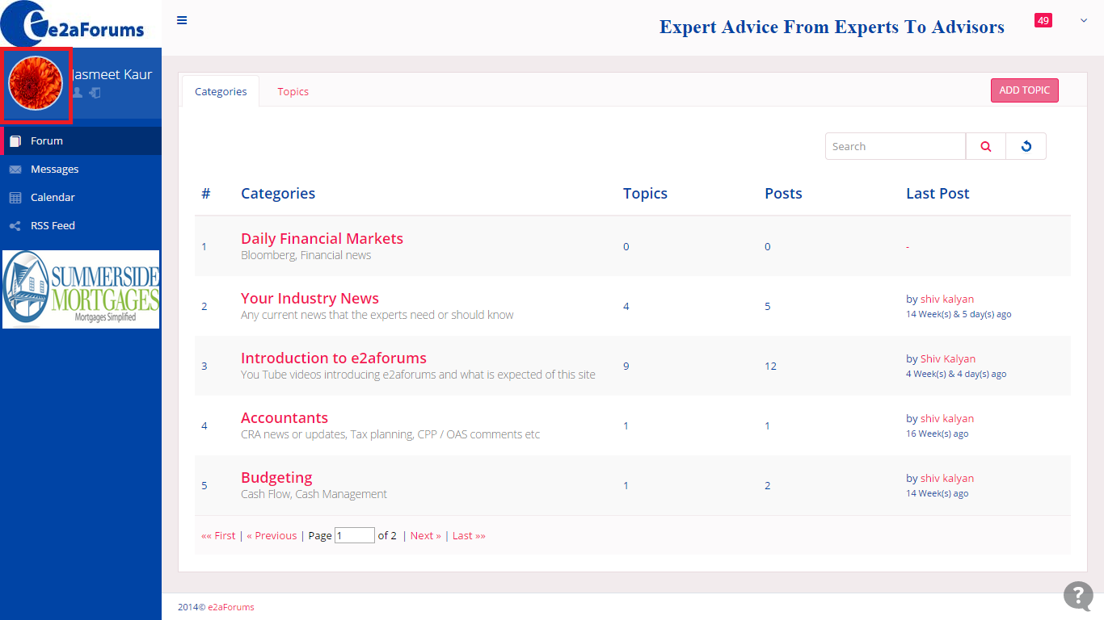

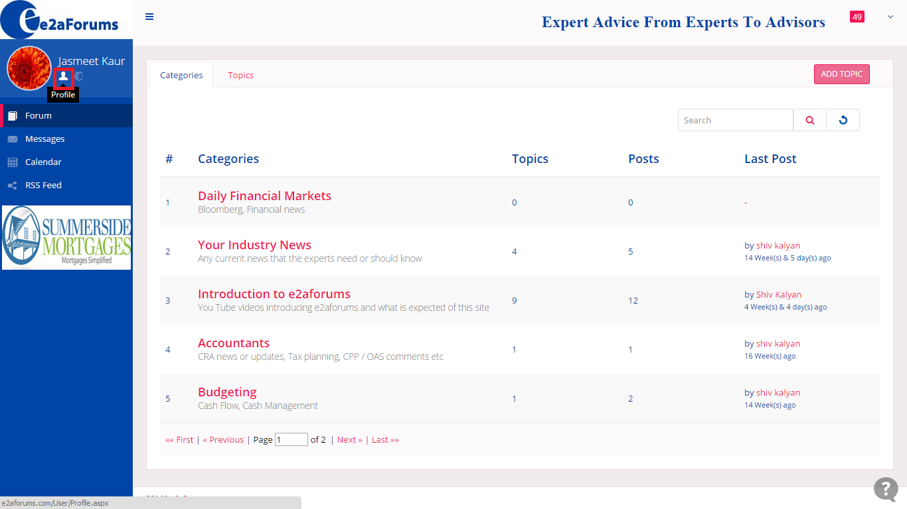

While on the click of red colored highlighted icon, user can view his/her own details as shown below:

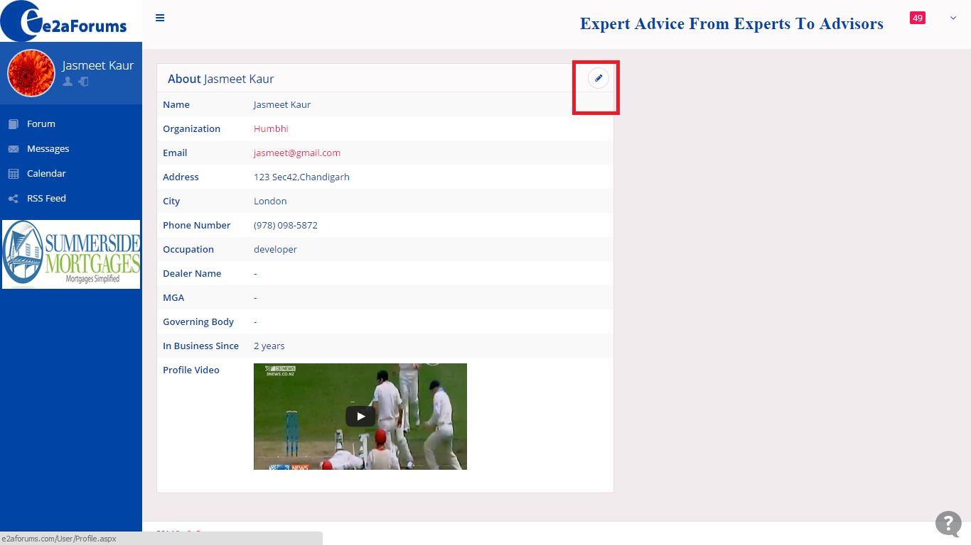

On the click of edit icon(highlighted with red color) , user get the edit profile form with pre-filled value in controls as shown below:

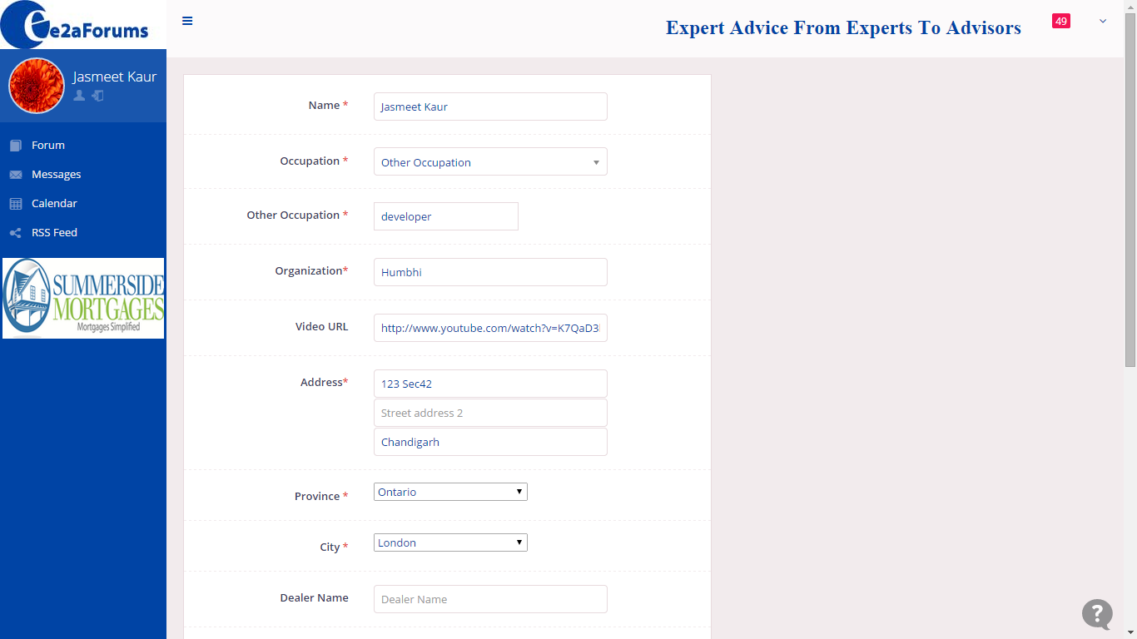

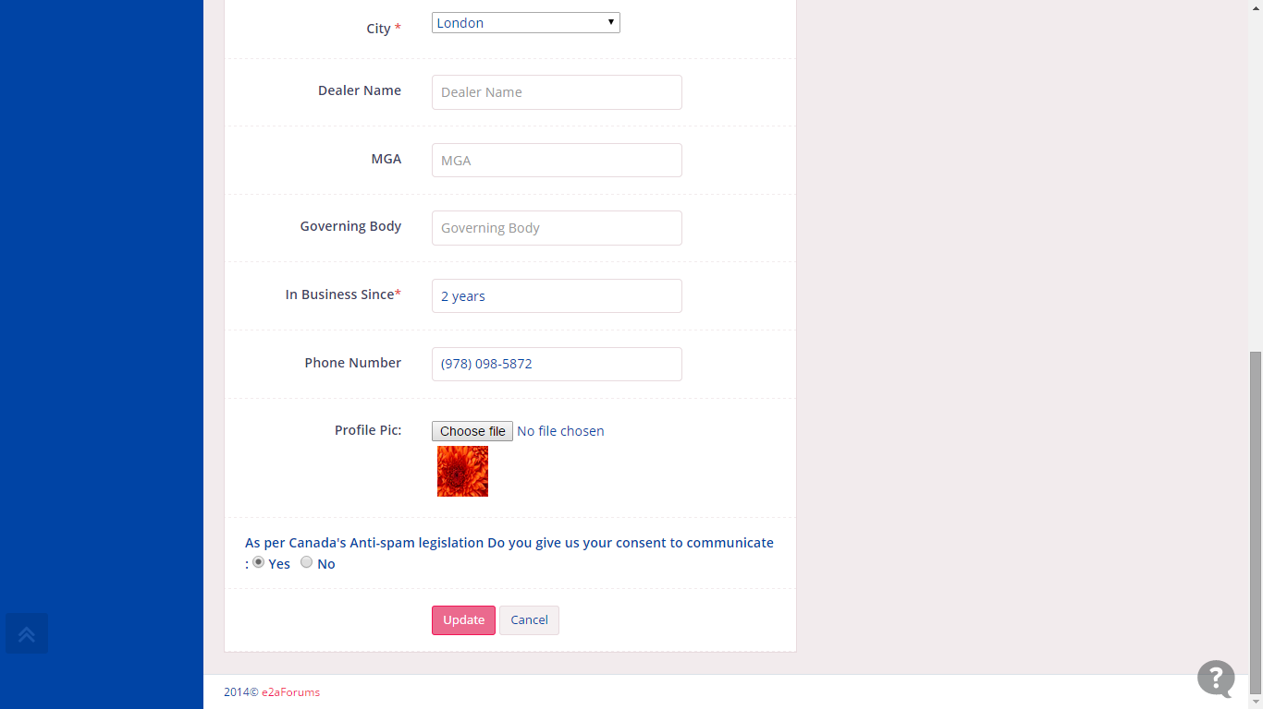

User select the profile pic for change his profile image and click on update button to save changes:

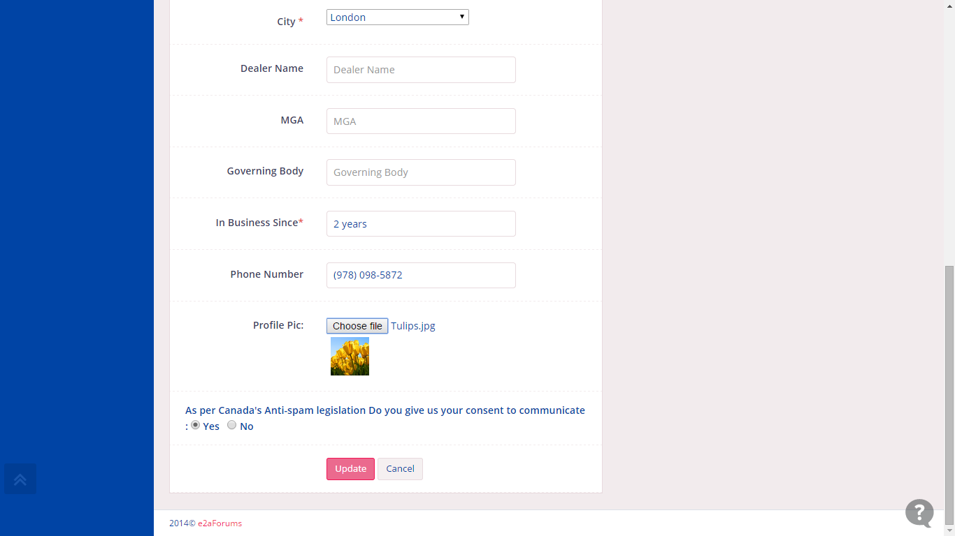

As the logged in user select the image as shown above and click on update button for save his change. After Click on update button user’s profile image updated as shown below:

